REGISTRATION FORM
FOR OFFICIAL USE ONLY:
Amount received: HK$ _____________________ Registration No.: _________________ Receipt No._______________

2016 AIRP COURSE IN HONG KONG
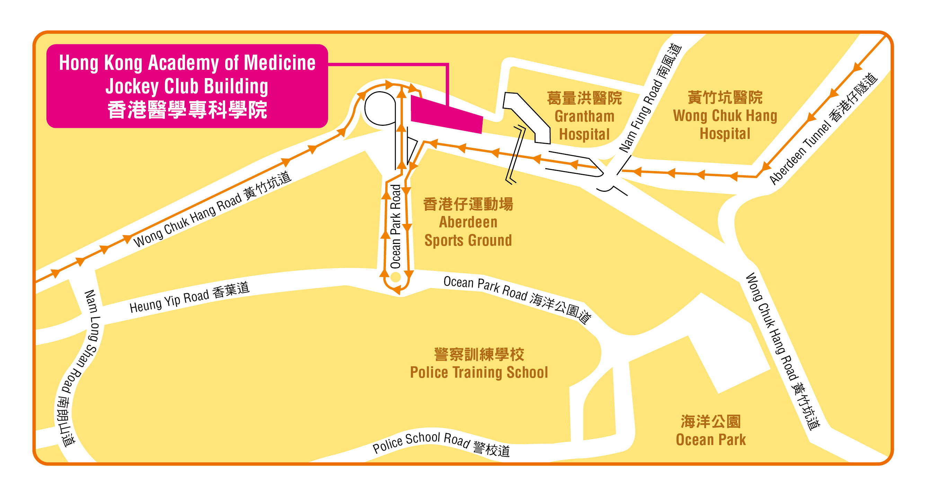
1st – 3rd July 2016 (Saturday & Sunday)

Venue: Hong Kong Academy of Medicine Jockey Club Building
99 Wong Chuk Hang Road, Aberdeen, HKSAR, China
香港黃竹坑道99號香港醫學專科學院賽馬會大樓
www.hkam.org.hk

(Each form should be used for one registration only. It can be photocopied, downloaded from www.hkcr.org)

Please return the completed registration form with payment to:
Conference Department  Hong Kong Academy of Medicine  Room 808, 8/F, HKAM Jockey Club Building  99 Wong Chuk Hang Road  Aberdeen, Hong Kong SAR, China  Attention: Registration Secretariat of  2016 AIRP Course in Hong Kong |  | Tel: (852) 2871 8787  Fax: (852) 2871 8898  Email: HKCR@hkam.org.hk  Please visit our website for updated information:  URL: www.hkcr.org

I. Identification (please use block capitals)
*Title: Prof. / Dr. / Mr. / Mrs. / Ms. *Status: Fellow / member of HKCR:  YES  NO
*Last Name: |  |  |  |  |  |  | *First Name:
Position: |  |  |  |  |  |  | Department:
*Organization / Institute:
*Mailing Address:
*Country:
*Telephone: |  | ( ) |  |  |  |  |  | Facsimile: | ( )
*E-mail address:

*Mandatory Field

II. Registration Fees & Method of Payment
Registration fees for delegates include a copy of programme book, coffee breaks and lunch(es) during the meeting period.
All bank charges must be pre-paid.
Preferred Copy of Programme Book:  Electronic Copy  Hard Copy
REGISTRATION FEES FOR LOCAL/OVERSEAS DELEGATES:
Discounted Rate for Early Bird Registration  (Before 30th April 2016 by postage chop) | - HKD 4,000 /  - USD 550
Full Registration (3 days) | - HKD 5,000 /  - USD 680
(The registration fees in USD as quoted above include bank charges for USD bank drafts.)

METHOD OF PAYMENT:
- Cheque in Hong Kong Dollars (HKD) made payable to “HONG KONG ACADEMY OF MEDICINE” enclosed. For overseas delegates, personal cheques are not accepted.
- Bank Draft in US Dollars (USD) made payable to “HONG KONG ACADEMY OF MEDICINE” enclosed.
- Payment by Credit Card in Hong Kong Dollars (HKD) for overseas delegates only. The following credit cards are accepted: VISA, MASTERCARD.
Please charge the total amount above to the following credit card:  Visa  MasterCard

Cardholder Name:
Credit Card No.: |  | Expiry Date: | ( mm / yy )
Cardholder Signature: |  | Date:

NOTE: Your registration will not be processed or confirmed if payment is not forwarded with this form.

III. CME/CPD Accreditation
The 3-day course is accredited by Hong Kong College of Radiologists for 21 (Cat. A) CME/CPD Credit Points. [7 points for each day]

CME/CPD credit points from The Royal College of Radiologists, other Colleges of the Hong Kong Academy of Medicine, MCHK CME Programme and Radiographers Board of Hong Kong are under application.

Please remember to register for your CME/CPD points on all days of the meeting. Programme may be subject to changes.

IV. Personal Data (Privacy) Ordinance
Your name and institute will be included in the list of participants, which may be distributed to delegates, speakers, sponsoring companies and other parties involved in this event and also for our College’s future scientific activities. Please tick box if you do not agree.
I would not like my name to be included in the list of participants. 

V. Cancellation Policy
In the event of cancellation, a refund of the total registration fee paid (minus a 25% administration fee) will be made, on provision of a written notice received by the Secretariat on or before 31st May 2016. After this date, no refund can be made for cancellation. Please note that all refunds will be issued only after the meeting. In case of cancellation due to bad weather or other uncontrollable factors, no refund will be entertained.

Signature: _____________________________________________ Date: _________________________________________

